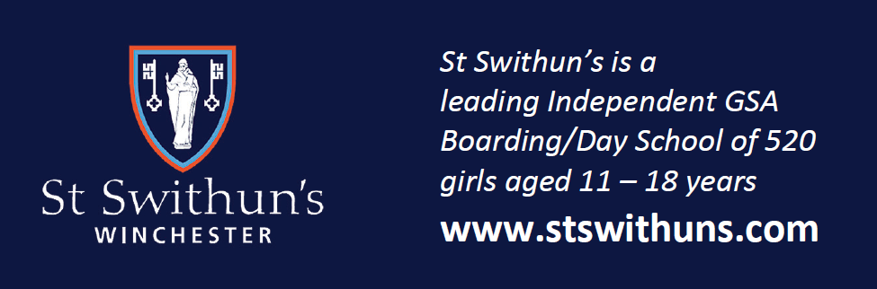

*St Swithun’s is a leading Independent GSA and HMC Boarding/Day School of 520 girls*

*aged 11-18 years*

Teacher of Classics

(0.6-0.7 approx)

Short-term cover

**Required as soon as possible**

The school seeks to appoint a well-qualified, enthusiastic and engaging individual to join the Classics department and deliver effective teaching and learning from Year 8 upwards. The department is a thriving one and seeks to deliver a positive experience of the ancient world to all students. This is a wonderful opportunity to enjoy working in a stimulating professional environment.

The ability to teach A-level Classical civilisation is a requirement of this post, and it would be an advantage to be able to teach Classical Greek GCSE, though this would not be essential. The successful candidate will be a positive and dynamic individual who is able to engage, motivate and inspire students of all ages.

St Swithun’s is a popular and successful selective girls’ school committed to

developing innovative teaching and learning; open communication with parents

and being a tolerant, kind and supportive community in which every pupil

feels able to try new challenges without fear of failure. St Swithun’s is proud to a High Performance Learning school and a member of the Fellowship of World Class Schools.

--

Early applications encouraged and will be considered on receipt

Further details of the post and an application form are available from <https://www.stswithuns.com/about-us/staff-vacancies> or

Mrs. Rachel Nicholls, executive assistant, recruitment@stswithuns.com or 01962 835701

*St Swithun’s is a registered charity providing education for boys and girls and is committed to*

*safeguarding and promoting the welfare of children. All staff are expected to share and*

*support this commitment and applicants must be willing to undergo child protection*

*screening appropriate to the post, including checks with past employers and the*

*Disclosure & Barring Service*