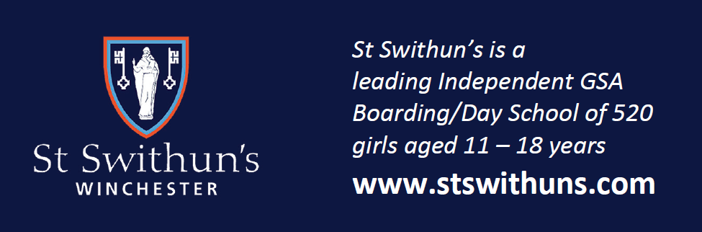

*St Swithun’s is a leading Independent GSA Boarding/Day School of 520 girls*

*aged 11-18 years*

Teacher of design & technology

(Part-time 0.3-0.4 fte approx.)

**Required for April 2025**

The school seeks a skilled and enthusiastic teacher to join the design & technology department. The successful candidate will collaborate willingly with positive-minded colleagues looking to develop teaching strategies in order to promote the subject and its place in the world today. They will be expected to teach across Key Stages 3 and 4. The ability to contribute to teaching A-level Product Design would be an advantage.

St Swithun’s is a popular and successful selective girls’ school committed to developing innovative teaching and learning; open communication with parents and being a tolerant, kind and supportive community in which every pupil feels able to try new challenges without fear of

failure.

--

**Closing date for applications: 9am, Monday 27 January 2025**

For further details of the post and to apply online please visit <https://www.stswithuns.com/about-us/staff-vacancies> or

Contact Mrs. Rachel Nicholls, executive assistant, recruitment@stswithuns.com or 01962 835701

*St Swithun’s is a registered charity providing education for boys and girls and is committed to*

*safeguarding and promoting the welfare of children. All staff are expected to share and*

*support this commitment and applicants must be willing to undergo child protection*

*screening appropriate to the post, including checks with past employers and the*

*Disclosure & Barring Service*