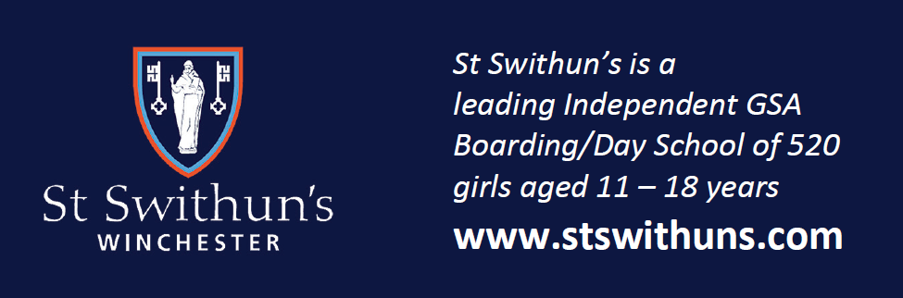

*St Swithun’s is a leading Independent GSA and HMC Boarding/Day School of 520 girls*

*aged 11-18 years*

HEAD OF GEOGRAPHY

**Required for September 2025**

The school seeks to appoint an inspiring head of geography to lead this popular academic department. The successful candidate will be an experienced geography teacher with exceptional subject knowledge, a strong work ethic and a desire to be part of the whole school community. They will be required to teach geography at all levels and prepare students for competitive university entry, plus have a passion for promoting learning within St Swithun’s and beyond.

St Swithun’s is a popular and successful selective girls’ school committed to developing innovative teaching and learning; open communication with parents and being a tolerant, kind and supportive community in which every pupil feels able to try new challenges without fear of failure. St Swithun’s is proud to be a High Performance Learning (HPL) school and a member of the HPL Fellowship of World Class Schools.

--

**Closing date for applications: Monday 27 January 2025, 9am**

For further details of the post and to apply online please visit <https://www.stswithuns.com/about-us/staff-vacancies> or

Contact Mrs. Rachel Nicholls, executive assistant, recruitment@stswithuns.com or 01962 835701

*St Swithun’s is a registered charity providing education for boys and girls and is committed to safeguarding and promoting the welfare of children. All staff are expected to share and support this commitment and applicants must be willing to undergo child protection screening appropriate to the post, including checks with past employers and the*

*Disclosure & Barring Service*